CONTACT ME

8919096566

haritha2000009@gmail.com

Hyderabad

SKILLS

Html

Css

Bootstrap

JavaScript

Java

React

springboot

HOBBIES

Listenind Music

Watching Tv

Browsing Net

Making Reels

STRENGTHS

Self Motivated

Quick Lerner

Flexible

DARUVULA HARITHA
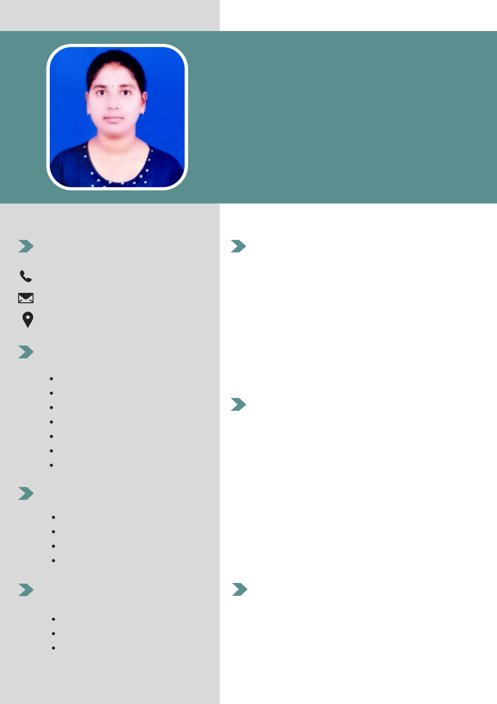

Certificate In Java Full Stack

PROFILE

I have good technical, communicational and analytical skills.Am adaptive person in new work environment. Passion for excellence. comprehensive problem solving abilities,exellent verbal and written communication skills, ability to deal with people diplomatically

EDUCATION

MSC(CS) at Central University Of Kerala 2020-2022 with 80%

BSC (MSCS) at palamuru university Mahaboobnagar 2017-2020 with 96%

10+2 at TSWRJC Jadcherla 2015-2017 with 80 %

SSC at ZPHS Rampoor 2014-2015 with 80%

CERTIFICATES

Certificate in Java Full Stack Development at Tech Mahindra Smart Academy

